The new ILCA 4 MK 2 Sails now available through Devoti Canada, Kingston

We have 10 of the new MK 2 sails for sale. Get one before they’re gone. Price is C$975, (plus batten set $85). Can be shipped or picked up at the CORK ILCA Canadians CORK Youthfest in August (where they’ll be legal for use). We also have Hyde ILCA 6 sails for sale.

Also available for purchase are two (2) ILCA 4 MK I sails at a deep discounted price of C$500.
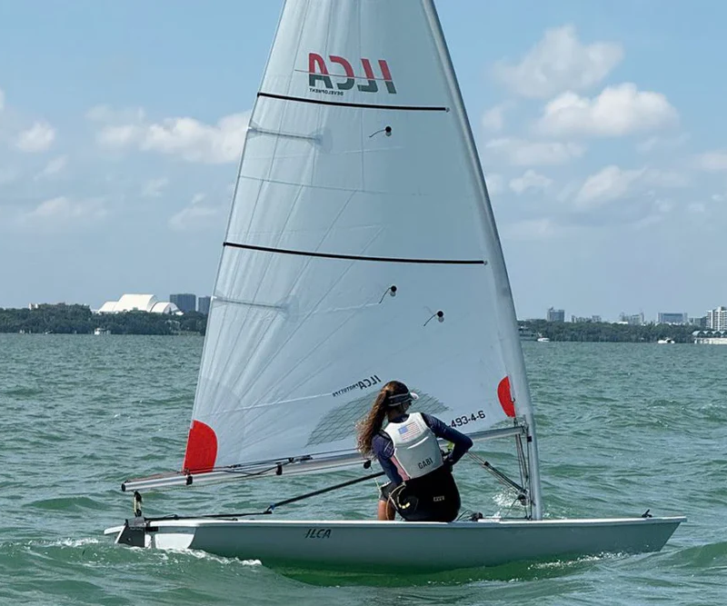
The new ILCA 4 Mk II uses a more robust 4.93 oz cloth and adopts a bi-radial construction better suited to modern stiffer materials. Additional updates include:
- A larger sail window
- Standardized reinforcement patches
- An updated batten configuration, aligned with the MkII sail family
- A look-and-feel closer to the ILCA 7 Mk II, improving consistency across the Mk II range
Battens: The new ILCA 4 MK II sail requires a unique batten set. Existing ILCA 4 MK I battens are not compatible.
Class Legal for Racing: The new ILCA 4 MK II sail will become class legal in early August 2026. (The current ILCA 4 MK 1 sail will remain fully class legal.)
Performance and Sailor Guidance
Overall performance remains comparable to the existing sail. Sailors report slightly improved responsiveness and a wider usable range, with additional camber available for lighter conditions and a greater ability to depower as the wind builds. The target sailor weight range remains 55–65 kg.
The MkII sail places greater emphasis on sail controls to tune the sail effectively, addressing a commonly raised limitation of the current ILCA 4 sail. As with the ILCA 7 MkII, sailors may benefit from higher Cunningham purchase ratios to fully access the sail’s depower range.
Reported Feedback from Testing
Feedback from sailors and coaches involved in the testing program has been strongly positive:
ILCA 4 Coach – USA
“The ILCA 4 sail tests are going really well. From my point of view, the new sail seems to be faster than the previous one. Its shape provides more tuning options, and it has everything it takes to become a big success.”
ILCA 4 Sailor – Europe
“The new sail feels really great – I think it can make the ILCA 4 even faster than before. It holds its shape really well so the power stays consistent while sailing, which makes the boat easier to push to its limits. For the ILCA 4 class, this feels like a big step forward and a really exciting improvement.”

